National Meet 2020
Accommodation
Rally Headquarters is at the Mercure Ballarat Hotel & Convention Centre
613 Main Rd, Golden Point VIC 3350
Please note that the following accommodation list is a suggestion only. Ballarat has lots of other venues however we have struck a discounted price at the following and they are close to the Rally Headquarters. When making your bookings please mention the Model A Ford Club National Meet otherwise the discount won’t be applied. We also advise that you have a look at the websites to make sure you are happy, it is your choice.
Accommodation rates are only valid until June 5th 2020
Mercure 613 Main Golden Point 3350 Ph: +61 (03) 5327 1200 Web: www.mercureballarat.com.au
Per Night Rally Headquarters
Double Room only - $160 per couple
Double Room and Breakfast 2 people $180
Single Room - only $149
Single Room and Breakfast $159
2 B’room Apartment (king bed & 2 Singles) full kitchen/laundry etc. $230 for 4
2 B’room Apartment (king bed & 2 Singles) full kitchen/laundry etc and Breakfast $250 for 2, $260 for 3 and $270 for 4
Please Note there are only 9 apartments, total number of rooms available 97. There are no toasters in Room and one cannot be used in room-If smoke alarm goes off you will be responsible for a very hefty Fire Brigade Call Out Fee. If you want to do your own breakfast bring your own bowls etc for cereal. However, as you will see it is only $10 pp. for full buffet breakfast daily.
Best Western Plus Ballarat Suites 525 Main Road Ballarat 3350 Ph: +61 (03) 5329 0200
Per Night Rooms have kitchenette with sink, bar fridge, kettle toaster etc. NOTE 2 Storey
Web www.ballaratsuites.com.au This motel is 230 m from rally Headquarters
Room Only $160 per couple .Room Service B’fast is available check when booking for costs. Total number of rooms available is 26.

Sovereign Park Motor Inn 217-229 Main Road Ballarat 3350 Ph: +61 (03) 5331 3955
Web www.sovpark.com This motel is 1.2k from Rally Headquarters. NOTE 2 Storey
Rooms have kitchenette with sink, bar fridge, kettle toaster etc. Total Number of rooms is 52
Per Night
Room Only $165 per couple Restaurant on Site B’fast available check price when booking.
Big 4 Goldfields Caravan Park 108 Clayton Street Ballarat 3350 Ph: +61 1800 632 237
Web www.ballaratgoldfields.com.au This park is 1k from Rally Headquarters Total of 42 Cabins
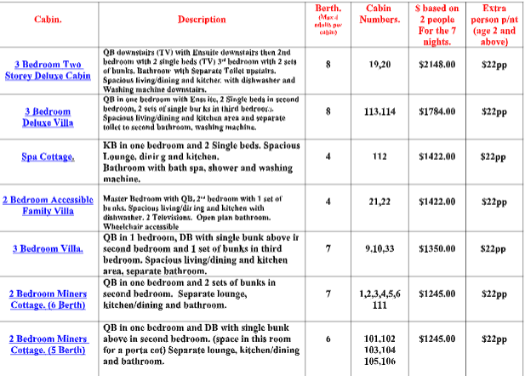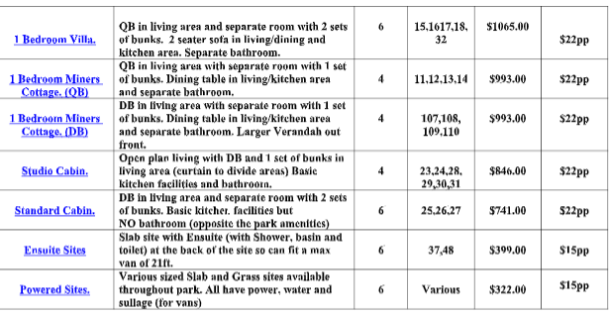
FURTHER 10% DISCOUNT ON THESE PRICES FOR BIG 4 CARAVAN PARK owner is a fellow Model A owner

